PRACTICAL 4
A)Create the ETL map and setup the schedule for execution.

Step1: Select OLEDB as a source and Excel Destination and sort.

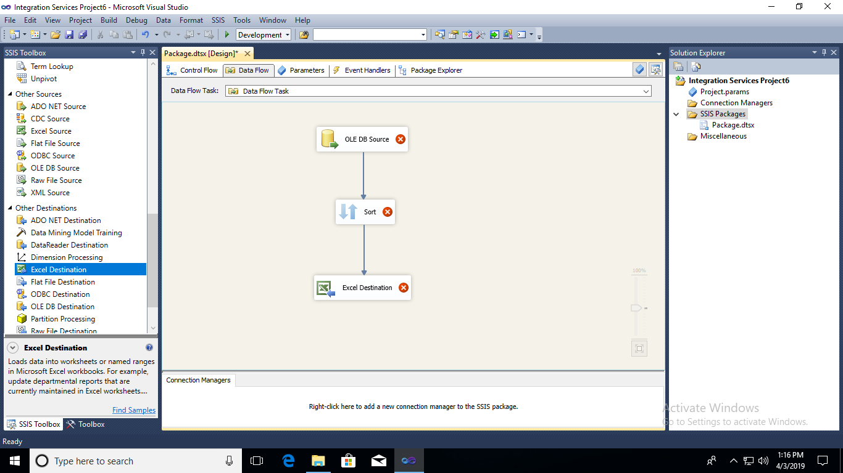

Step2: Select OLEDB source->Edit->select Adventure Works 2012 database->choose [Sales.Customer] table ->click on ‘OK’
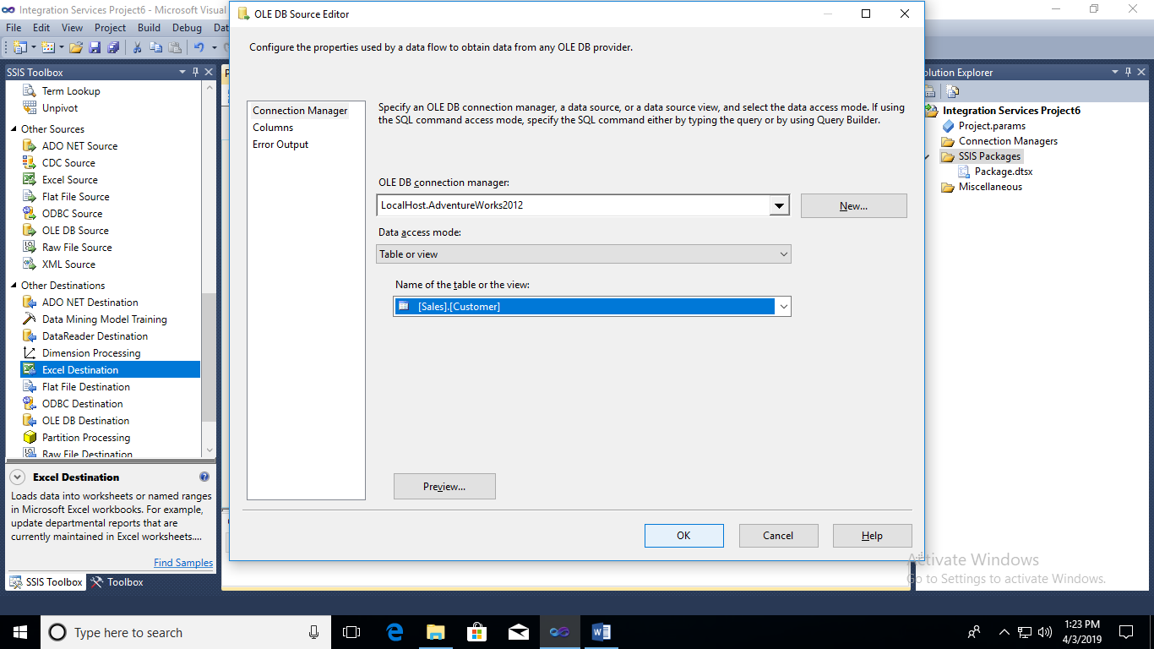
Step3: Click on Sort -> Go to Edit-> select Column names.
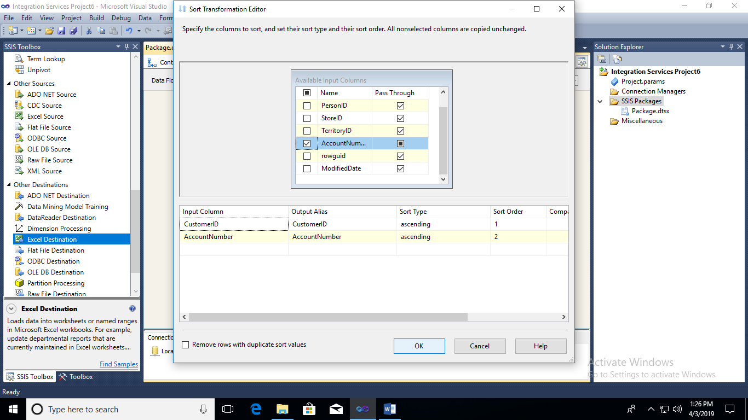
Step4 : Create new Excel File and save the file.
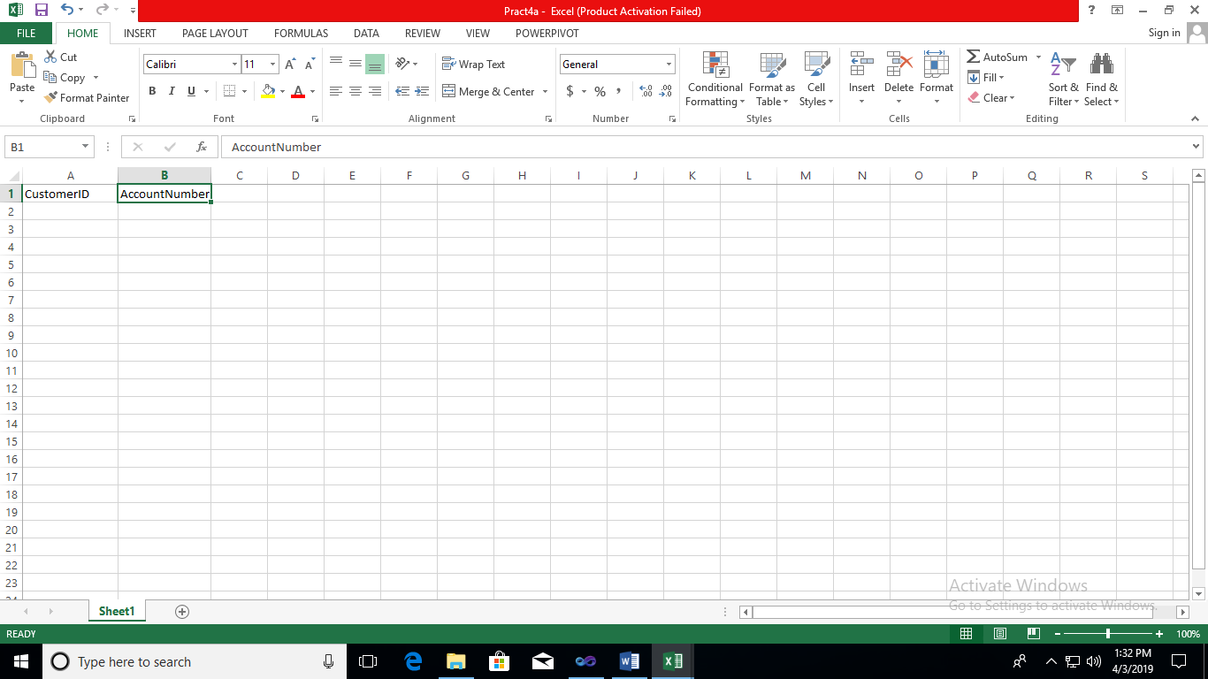
Step5 :Select Excel Destination ->Edit->Select (Saved Excel File)”pract4a.xmls” -> Click on OK.
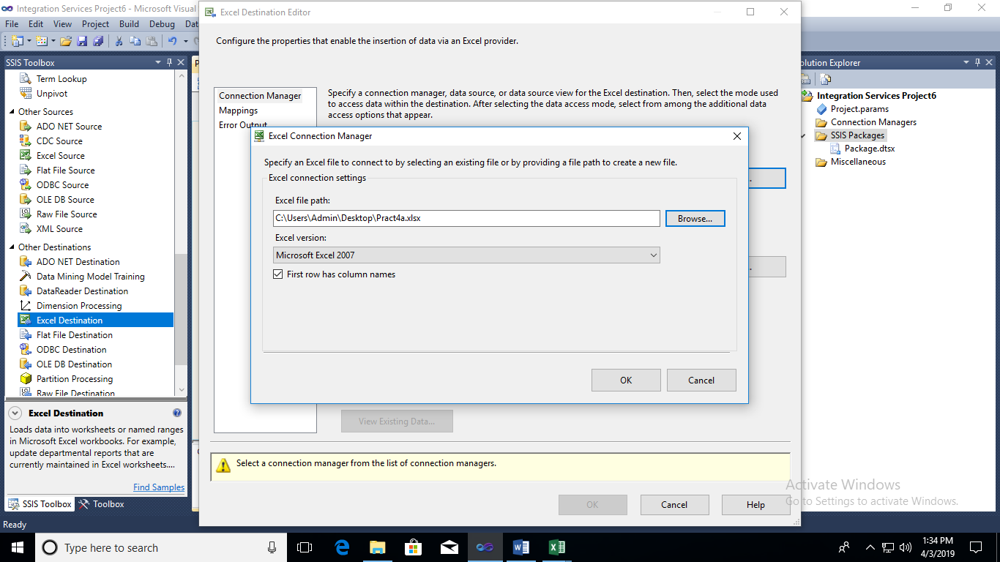
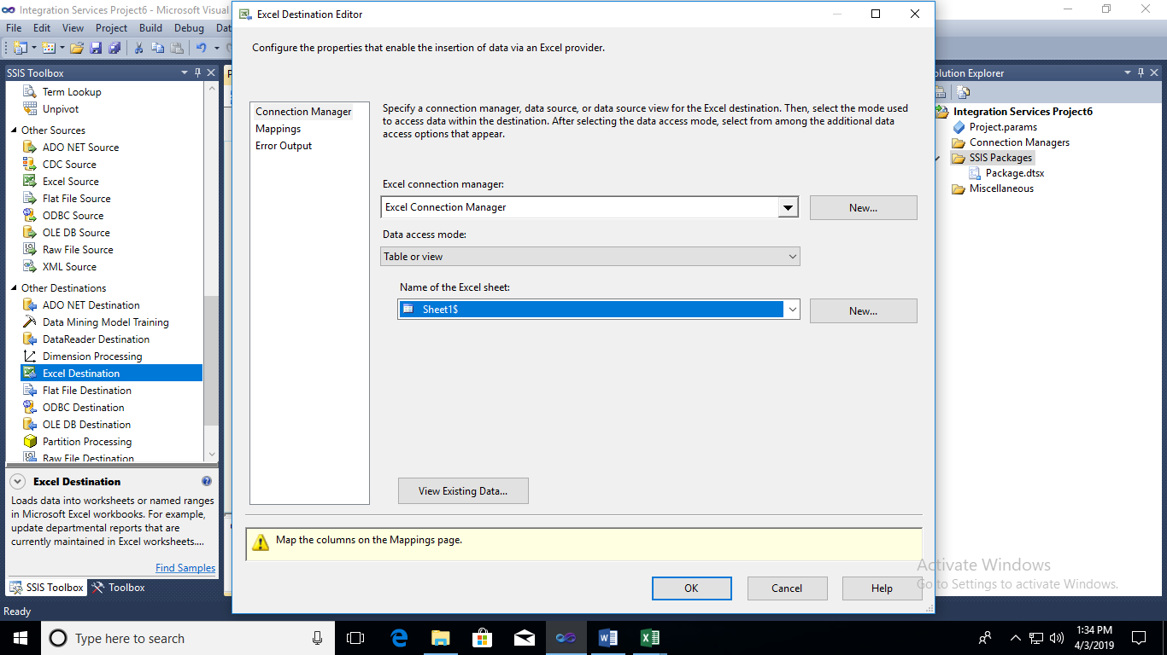

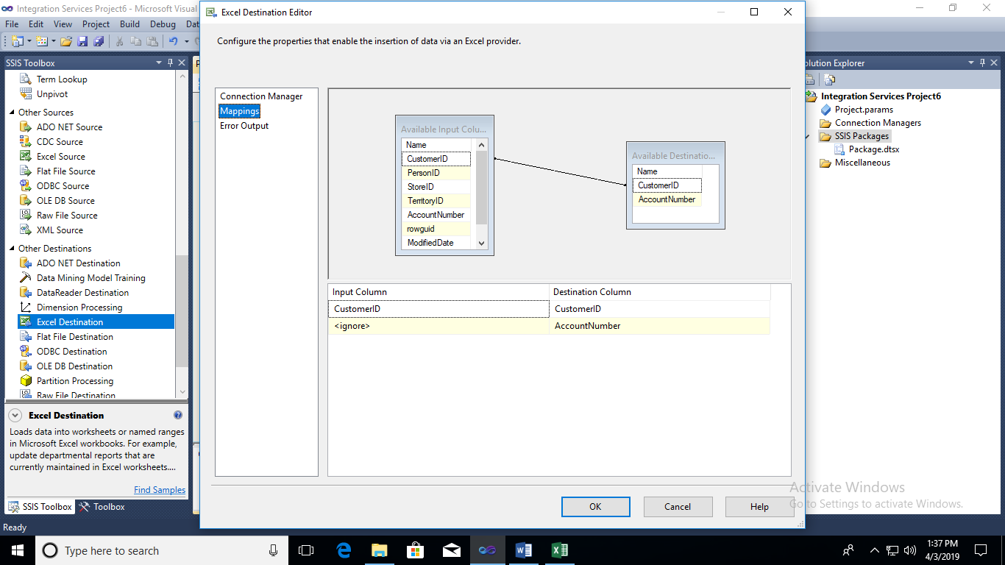
Step 6: Open SQL Management Studio.
Step 7: Go to SQL Server Agent -> Expand -> Right Click On Jobs -> New Job
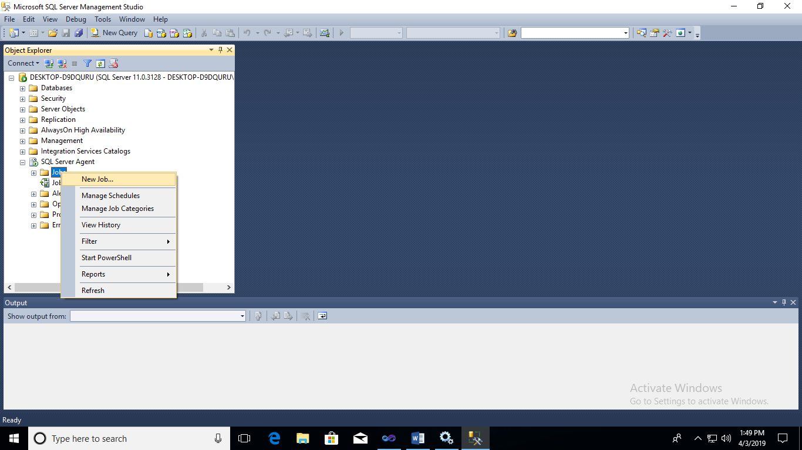
Step 8: Give Name for the job.
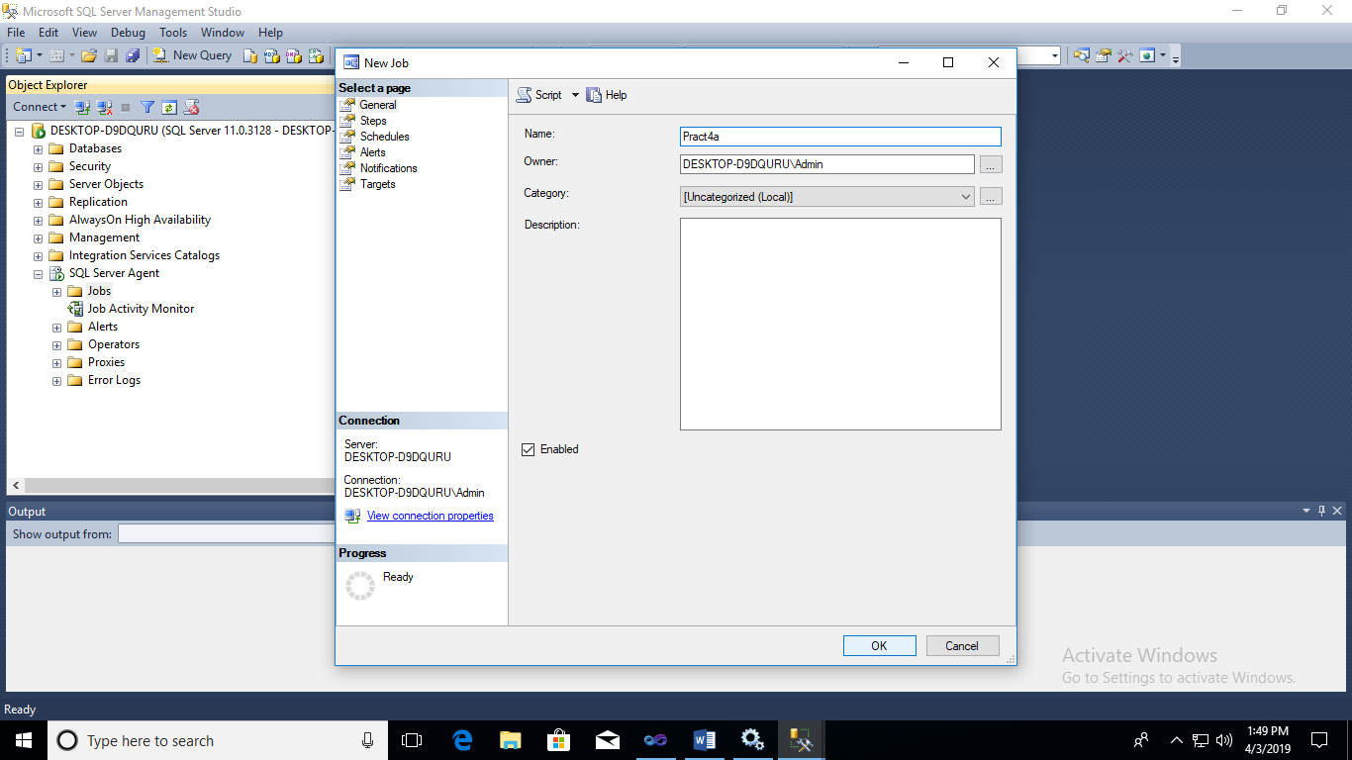
Step 9:go to Steps-> Give Step Name as “Step1” and Give Type as Transact-SQL.Script.
Choose database as Employee and Command As Follows:
1.use Employee ;
2. Insert into dbo.EmployeeValues(1,”ABC”,10000,”HR”);
Click on OK.
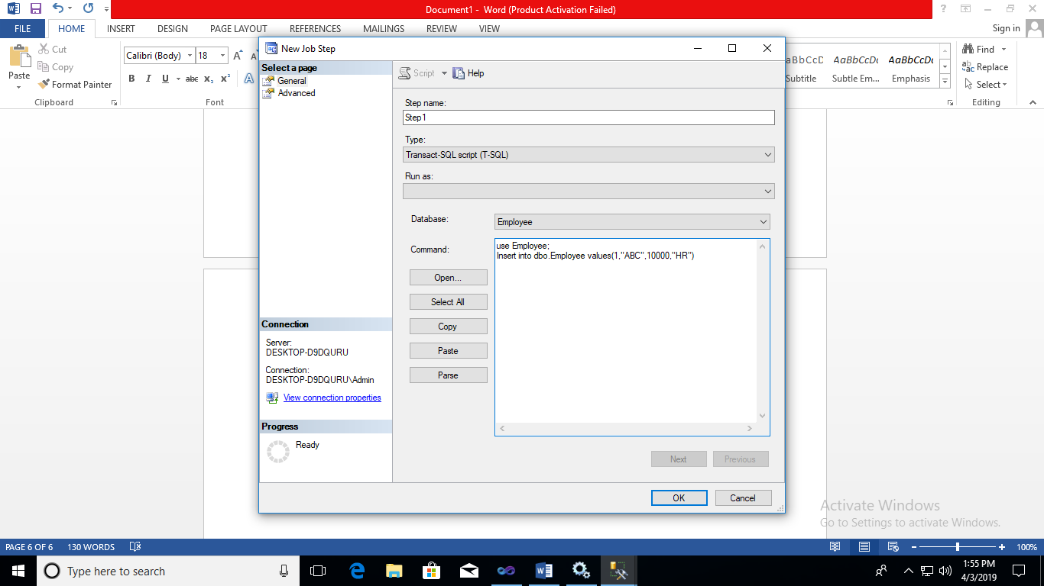
Step 10: Go to Schedule click on New give name for schedule as Schedule1 And Schedule Type as OneTime and select time for schedule.-> click on OK.
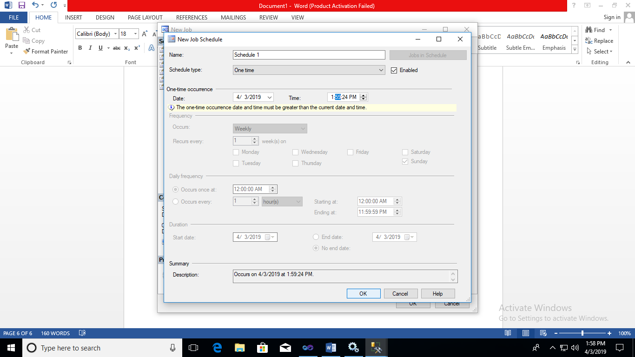
Step 11: go to SQL Server Agent -> Jobs -> (Expand) Job and Schedule are added.
Step 12: Refresh the Employee table ->Edit top 200 rows. ->data will be added.
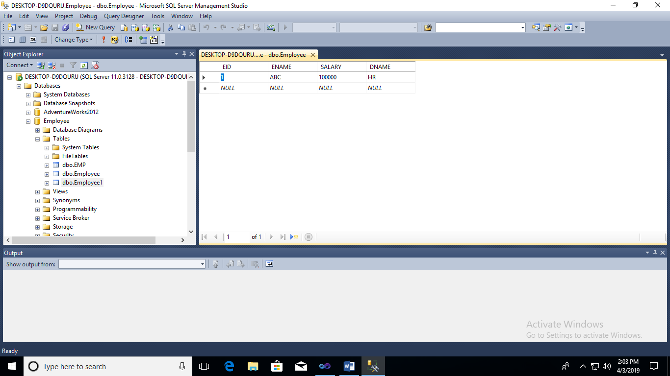
Step 13 : go to SQL Agent-> jobs-> Right click-> view History

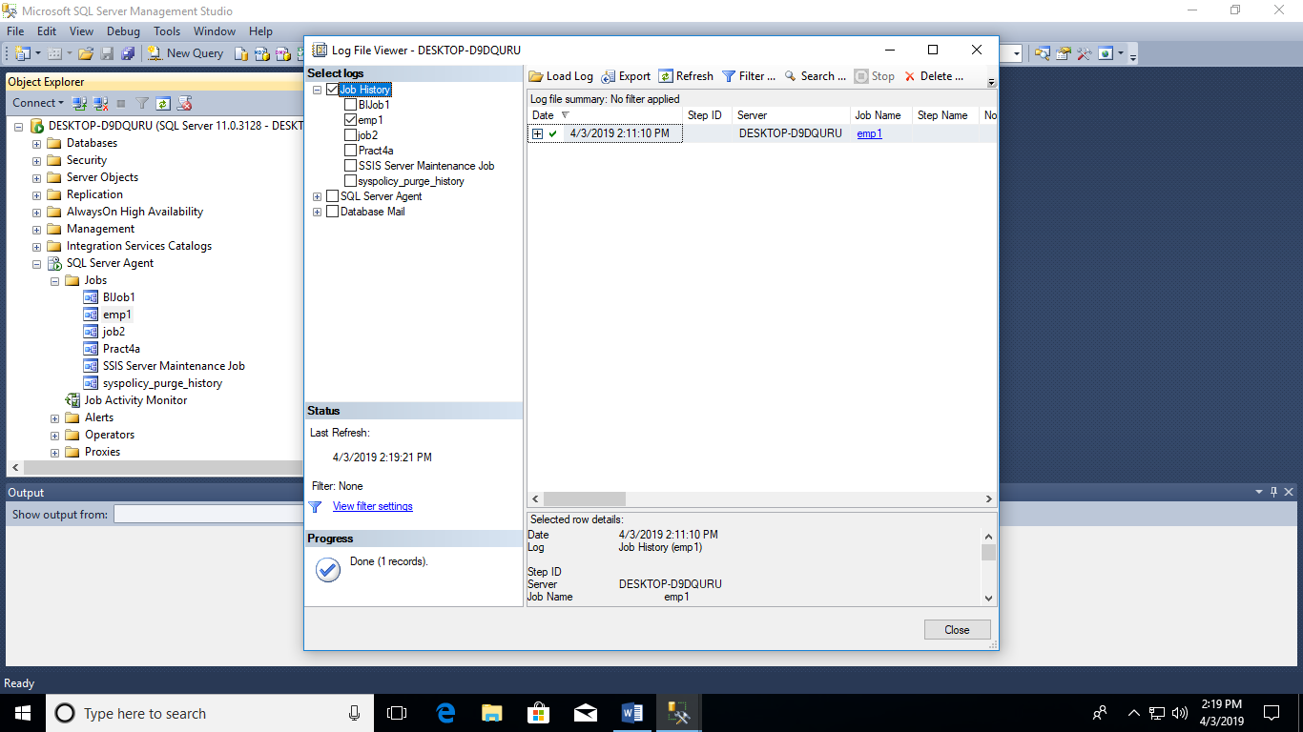
NOTE: if integration service catalog is disabled
Step 14: go to Integration service catalog-> Right click-> Create new catalog-> check the “Enable CLR integration”
Password:vaze
Retype Password: vaze
Click on OK.
Step 15: go to integration service catalog ->(Expand)SSISDB->Right click->Create->give Folder Name:Folder1->Click Ok
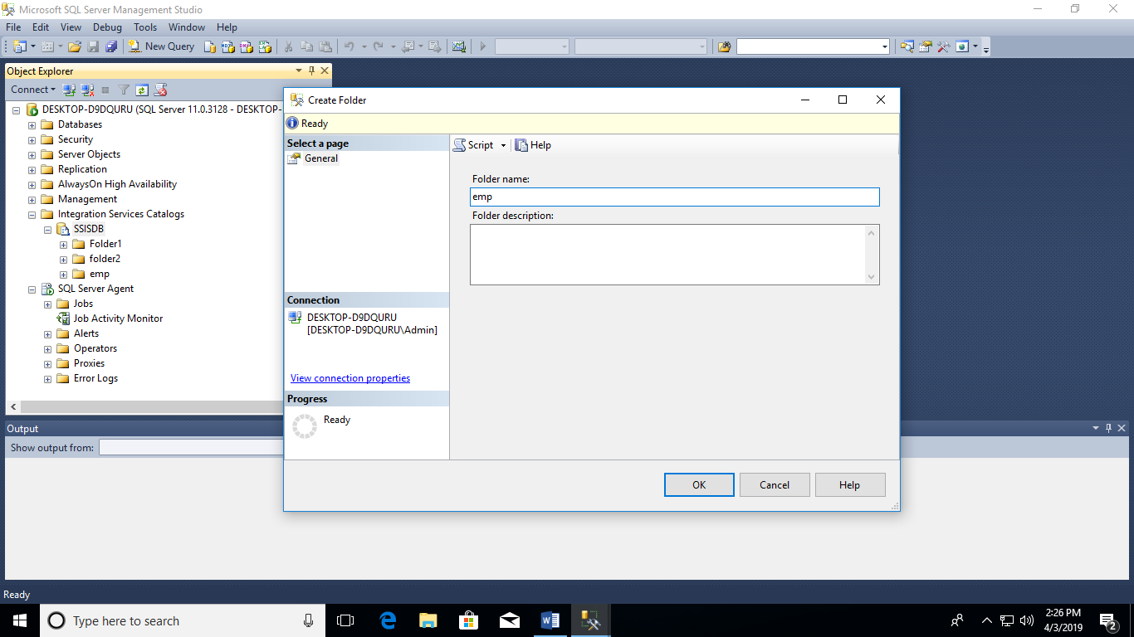
Step 16:Go to Integration Service Catlog(expand)-> SSISDB(Expand)emp (Expand)->Right click on project1->Import package->select package from path where the Integration services project are stored
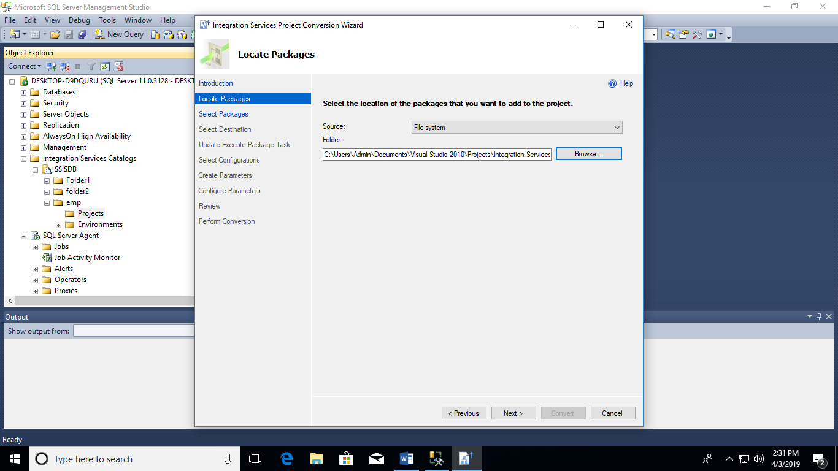
Step 17:click on next -> check for the package as package.dtsx-> click on next till convert-> click on convert-> close
Step 18:right click on projects-> next-> chose path
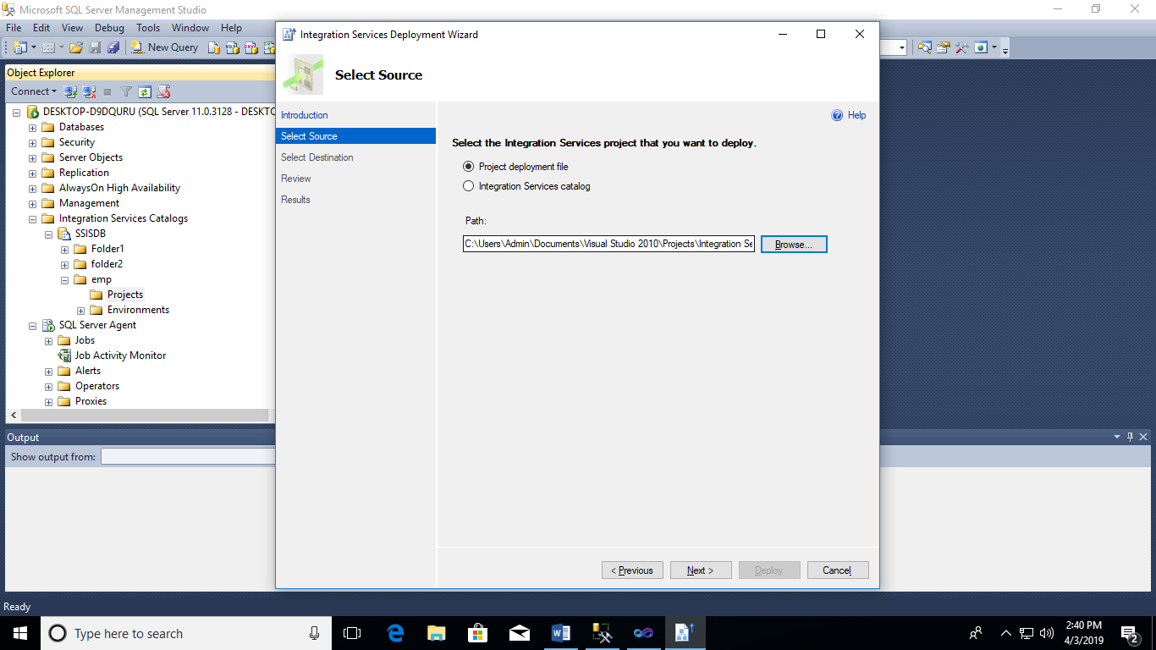
Step 19: deploy the project
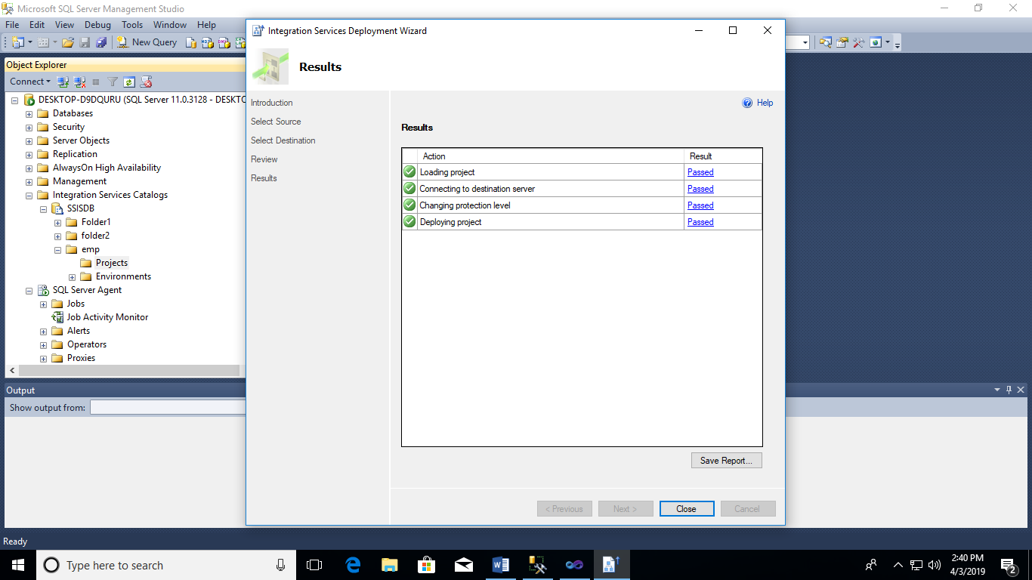
Step 20: go to integration service catlog->SSIDB->emp->Projects->project1(expand)->check for prac4a file
Step 21: go to SQL server agent -> create new job-> go to steps->click on ok
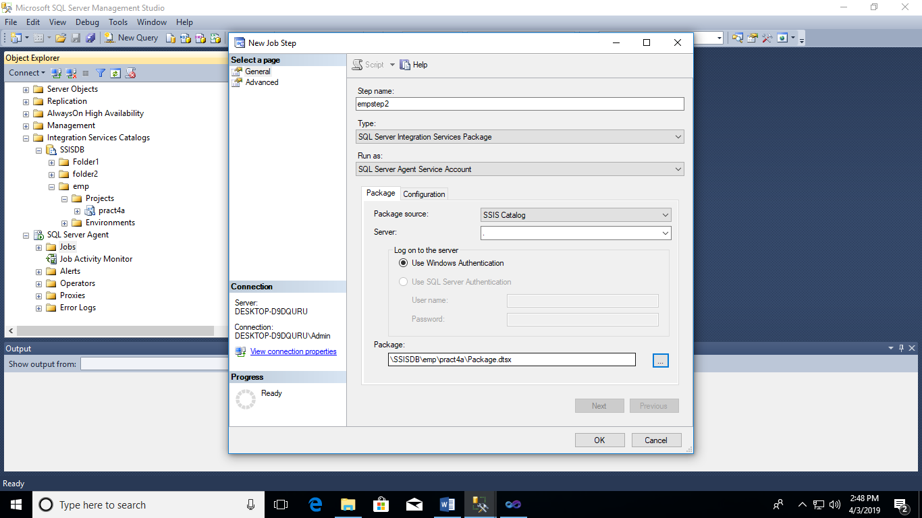
Step22 :create new schedule-> click ok
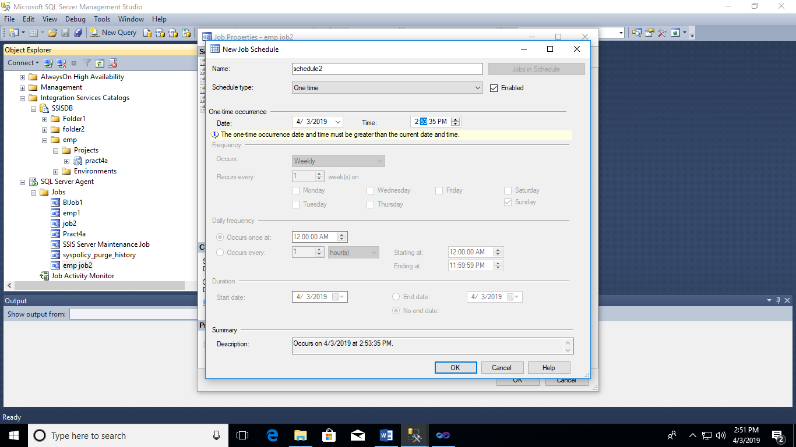

Step 23: Right Click on JOB ->View History.
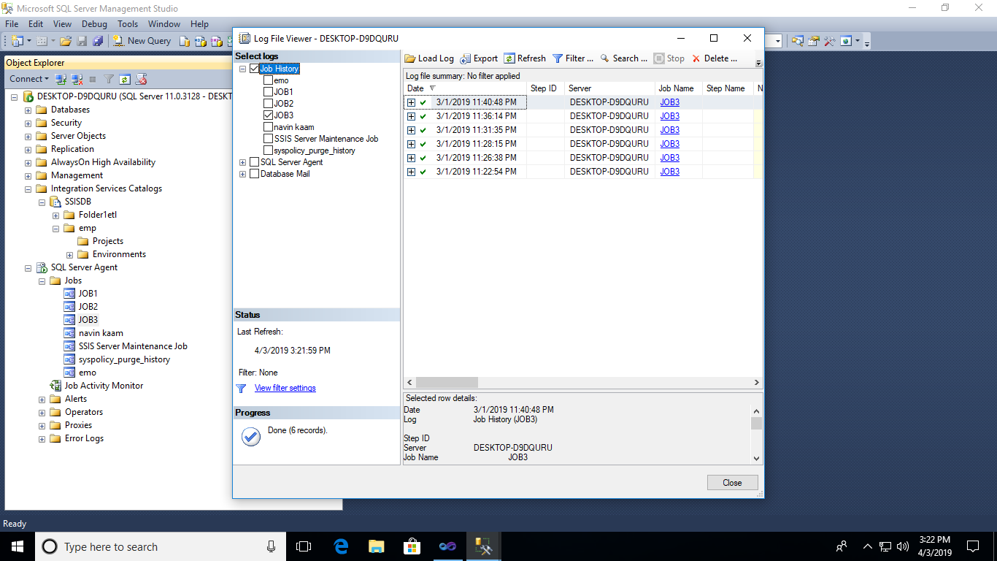

Step 24: Check Excel File data .

PRACTICAL 4 b
Execute the MDX queries to extract the data from the datawarehouse.
Step 1: Open SQL Server Management Studio and connect to Analysis Services.
Server type: Analysis Services
Server Name: (according to base machine)
Click on connect

Step 2: Click on New Query & type following query based on Sales_DW
select [Measures].[Sales Time Alt Key] on columns
from [Sales DW]
Click on execute
select [Measures].[Quantity] on columns
from [Sales DW]
select [Measures].[Sales Invoice Number] on columns
from [Sales DW]
select [Measures].[Sales Total Cost] on columns
from [Sales DW]
select [Measures].[Sales Total Cost] on columns
, [Dim Date].[Year].[Year] on rows
from [Sales DW]
select [Measures].[Sales Total Cost] on columns
, NONEMPTY({[Dim Date].[Year].[Year]}) on rows
from [Sales DW]
select [Measures].[Sales Total Cost] on columns
from [Sales DW]
Where [Dim Date].[Year].[Year].&[2013]

